

Low Level Design (LLD)

Architecture

Random JokesApp

ASIBUL HASAN

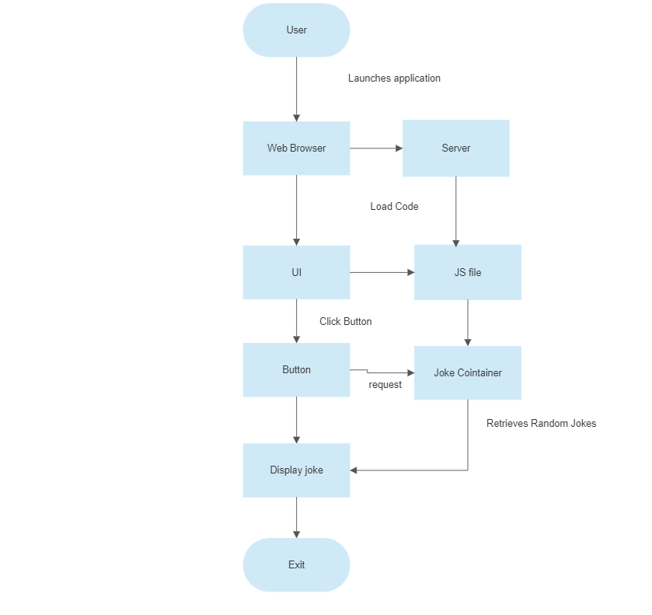

**User interface (UI):** This component is responsible for displaying the jokes to the user and allowing them to interact with the system. It could include the homepage with the "Generate Joke" button, the joke display page, and the joke submission form.

**Joke database:** This component stores a collection of jokes, organized by category. It could be implemented using a database management system such as MySQL or MongoDB.

**Joke generator:** This component is responsible for selecting a joke from the database and presenting it to the user. It could use a random number generator to choose a joke at random, or it could take into account the user's selected category and ratings to make a more personalized selection.